What is GITHUB?
GITHUB is a REPOSITORY/REPO

What is REPO?
COLABORATOR STORAGE of SOURCE-CODE/SRC

Who are COLABORATOR?
Multiple people work together on SRC and put them in a Common Storage

Who are the PLAYERS in GITHUB?

GITHUB ADMIN > “n”REPOSIOTORY > “n”BRANCHES > “n”SUB_BRANCHES > “n”COLABORATORS

What are the Actions of the PARTICIPANTS?
- Collaborator PUSH code to his own Repo or Collaborator will PULL code from Repo
- SLAVE Branch will raise PULL REQUEST to MASTER Branch
- MASTER Branch MERGE PULL REQUEST to the own Branch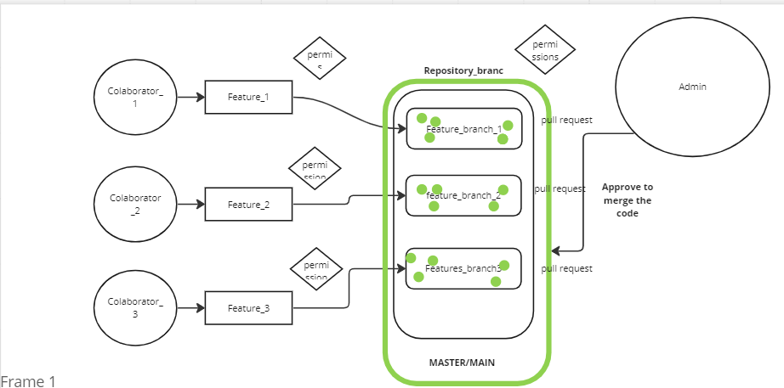


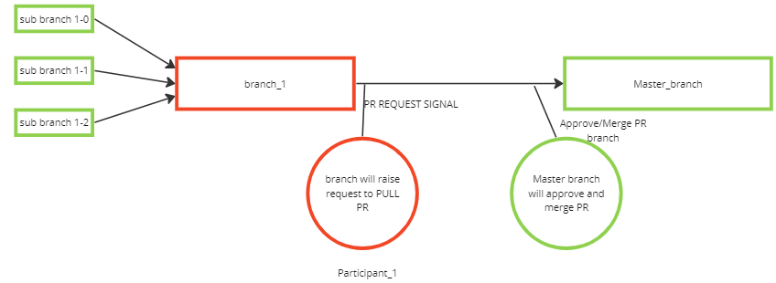

What are the actions can be done in GITHUB ACCOUNT?
- Create REPOSITORIES
- Give Access/Add to COLLABORATORS/GROUP to the particular REPO
- Generate PAT (Personal Access Tokens)
- FORK Other GITHUB Account REPOS
- STAR/LIKE others GITHUB ACCOUNTS for future notification

FORK vs STAR!
FORK: Get the COPY of REPO to the personal GITHUB account from Other GITHUB account
STAR: Get NOTIFICATIONS from the particular GITHUB Account

What are the TYPE of REPOS?
- PUBLIC Repo #Can be seen by any other GITHUB ACCOUNTS
- PRIVATE Repo #Restricted to only COLLABORATORS/GROUPS in the GITHUB

If The any user want to get code from a repo how will he be given ACCESS?
User will be given PAT to Authenticate the branch for a span of time by the ADMIN

I want some SERVER to get the code access to the repo. What should I do?
ADMIN will create PAT and CONFIGURE the SERVER in GITHUB

HOW to Rise PULL REQUEST
LOGIN GIHUB > Repository > PULL REQUEST

What is the identification of the Repository
GITUB ACCOUNT has https URL
REPOSITORY has https URL ssh URI

